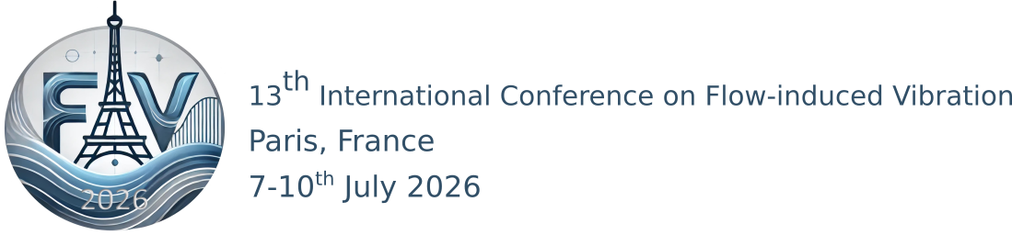

FIV2026 -XXX
Title

John Doe¹, Jane Smith¹, Alice Johnson², Bob Brown³, Charlie Davis^{2,3}
¹ Department of Physics, University of Somewhere
² Department of Chemistry, University of Anywhere
³Department of Mathematics, University of Everywhere

Authors of papers to proceedings have to type these in a standardized form in order to ensure uniform style throughout the volume. The reference format for submitting papers is PDF in A4 size. The publisher will reduce the PDF file to 82% and print it in black only.
For the convenience of the authors, template files are provided. This is the Word template (A4 size paper). It is suggested to start by directly editing or inserting text in this file. The expected paper length is between 6 and 8 pages.

Keywords : Food, FIV, Paris, ….
- Introduction
This is the introduction ….

- About citations
In the text, use authors' last names with the year of publication in parentheses as done by (W. Benguigui, 2023). If there are more than two authors, use "et al", e.g. (Goldstein, 1996). You can also use the form (author, year) as in (Sun, Roth, & Black, 2010 ). If there are multiple citations, use (;) as in (Peskin, 2018).
At the end of the paper, list all references in alphabetical order underneath the heading REFERENCES.

- about section titles
  - Subsection title

    - Subsubsection

- about equations, figure and tables

  - Figures
All authors must obtain the necessary permissions and licenses to reproduce figures, which should be submitted along with the production files. The preferred formats for figure submission are vector PDF or EPS, with editable labels and colors in RGB format. Bitmap/raster formats at a minimum resolution of 300 dpi (EPS, PNG, TIFF) are also acceptable for mixed halftones, photographs, imaging system outputs, etc.
Figure 1 is a photograph of the Plateau de Saclay, EDF Lab in foreground and Ecole polytechnique in background.

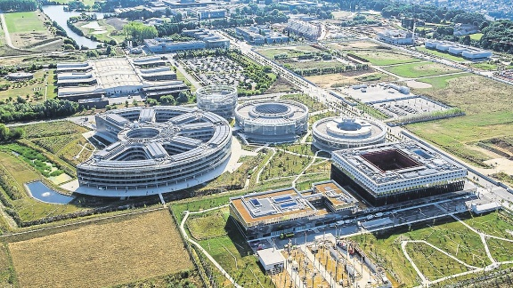
Figure 1: The magnificent Plateau de Saclay

  - Tables
Table 1 give values of parameters for FIV2026 papers
 | cm | Inches
Text Width | 17 | 6.69
Text height | 24.7 | 9.45
Top margin | 1.5 | 0.39
Table 1 : A4 size paper settings

 | - | -
Font | Times New Roman
Font Size | 11 | -
Text property | Justified | -
Table 2 : Font parameters

  - Equations
A typical equation should have the form of equation (1). (use of a table for the equation in Word)
$mh_{b}^{2}\frac{d^{2}θ}{dT^{2}}+C\frac{dθ}{dT}+K_{T}θ=0$ | (1)
$$ab=c$$ | (2)
  - Author ORCID
Authors may include their ORCID identifers as follows. J. Doe, https://orcid.org/0000-0001-6155-6444; J. Smith, https://orcid.org/0000-0009-8765-4321
- Conclusion
For any questions: https://fiv2026.sciencesconf.org/

REFERENCES
Goldstein, R. (1996). Fluid Mechanics Measurements (2nd ed. Routledge.
Peskin, C. (2018). Flow patterns around heart valves: A numerical method. Journal of Computational Physics.
Sun, D., Roth, S., & Black, M. J. (2010 ). Secrets of optical flow estimation and their principles. IEEE Computer Society Conference on Computer Vision and Pattern Recognition. San Francisco, CA, USA : IEEE.
W. Benguigui, C. P. (2023). Experimental investigation on two-phase cross-flow-induced vibration of a cylinder in a confined channel. Journal of Fluids and Structures.

